Tuesday, 30th March 2021

Tuesday, 13th July 2021

Tuesday 5th October 2021

Approx: 0830am – 1530pm
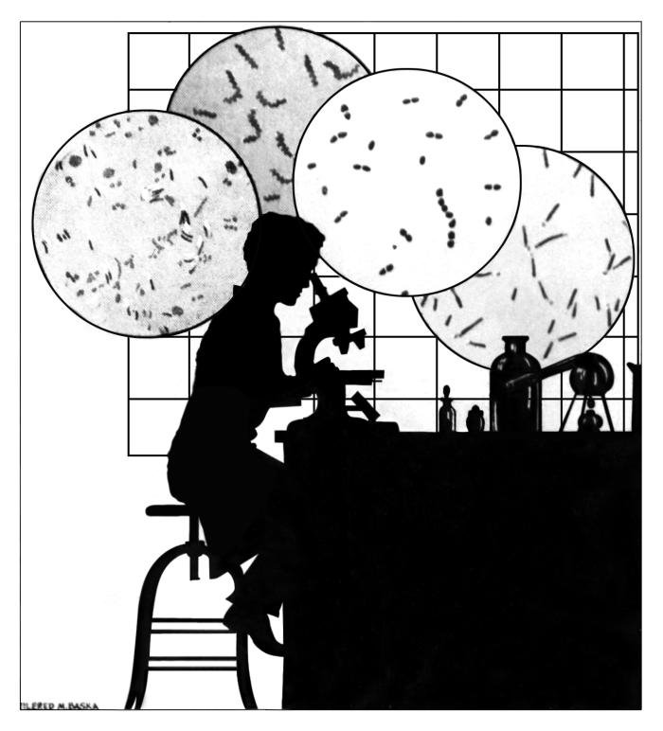

Morning tea will be provided.

Please bring your lunch.

LabPlus Career / Education Visits

Visit Dates: Tuesday 30th March 2021 (Registration Closes: Friday, 26th March 2021)
Tuesday 13th July 2021 (Registration Closes: Friday, 9th July 2021)
Tuesday 5th October 2021 (Registration Closes Friday 1st October 2021)

Report to: LabPlus Visitor Reception, Level 3, Building 31, Auckland City Hospital, Park Rd, Grafton, Auckland.

Name
Postal address
School / Tertiary - currently attending
School / Tertiary - current year
Experience (if any)
Please briefly explain your Laboratory experience
Phone contact | Home: |  |  | Mobile
Email address
Date I wish to attend | Tuesday  30/03/2021  □ |  | Tuesday  13/07/2021  □ |  |  | Tuesday  5/10/2021  □
Morning Tea will be provided.
Please bring your own lunch.

Please complete this registration form and return via post or email to:
Tracy Camp
Training and Development Lead
LabPlus – Administration
PO Box 110031
Auckland City Hospital
Auckland 1148

Email: tcamp@adhb.govt.nz
Phone: 09 307 4949 extension 22638

On receipt of your registration form, an email will be sent to you confirming your attendance.

